NDA Alumnae Spirit Wear Order Form

Name:

Address:

Contact Phone Number:

Payment Type: Ck#_____ CC: Visa, MasterCard #________________exp_______

1/4 Zip Sweatshirt: $28.00 QTY:
Please Circle Preference
Gray S M L XL 2XL 3XL
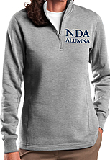 Navy S M L XL 2XL 3XL

Pullover Hooded Sweatshirt: $22.00 QTY:
Please Circle Preference
Gray S M L XL 2XL 3XL
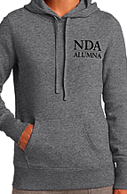 Navy S M L XL 2XL 3XL

Full Zip Hooded Sweatshirt: $28.00 QTY:
Please Circle Preference (Sweatshirt will not have white box)
Gray S M L XL 2XL 3XL

Navy S M L XL 2XL 3XL

Total Order: ________________Total Amount Due: ________________
Office Use Only: Paid: Y / N Delivered/Pick-up:

